.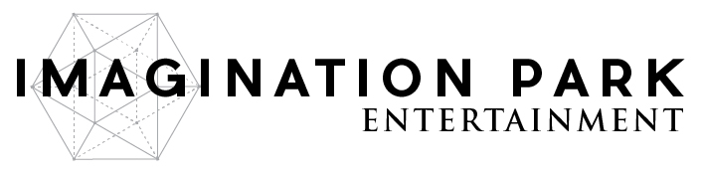
XenoHolographic Product Launch:
XenoRoom & XenoSidekick
to Launch November 28th

Vancouver, B.C. – November 14, 2017 – Imagination Park Entertainment Inc. (CSE: IP) (OTC: IPNFF) (FRA: GMS1) (“Imagination Park” or “Company”) and InterKnowlogy LLC are pleased to announce XenoHolographic Inc.’s (“XenoHolographic”) initial two products, XenoRoom and XenoSidekick, are scheduled for launch and release into the global marketplace beginning November 28, 2017. XenoRoom and XenoSidekick will, when launched, reduce the friction for consumers and companies as they deliver interactive holographic experiences to their users. XenoRoom is a location-based holographic experience engine allowing businesses to upload 3D content to the cloud and automatically download and render it. XenoSidekick is a toolkit developed to allow for seamless interaction with holograms irrespective of the augmented reality headset brand.
Alen Paul Silverrstieen, CEO of Imagination Park and a director of XenoHolographic stated: “We are excited to introduce our first two augmented reality products to the world this month. XenoHolographic is positioned to be a leader in the AR marketplace and optimistic to be generating revenue in 2018. In addition, XenoPlayer, our mobile AR app, is targeted to be launched by the first quarter 2018.”
Additionally, the Company announces the acceptance of a short term, no interest, C$500,000 bridge loan from a director of Imagination Park convertible into 2,500,000 common share purchase warrants of the Company, each warrant convertible into one common share at a price of C$0.32 per share for up to two years from the date of issue.
Further, the Company announces it has closed a non-brokered private placement financing (the “Private Placement”) for aggregate gross proceeds of C$60,000.
The Company has issued 187,500 units (the “Units”) at a price of C$0.32 per Unit. Each Unit comprised of one common share and one-half of one non-transferable share purchase warrant, with each whole warrant (a “Warrant”) entitling the holder to purchase one additional common share of the Company for a period of up to twenty-four months from the date of issue at a price of C$0.37, subject to accelerated expiry in certain circumstances.

The net proceeds of the Private Placement will be used to aid in the Company’s ongoing efforts to create and deliver transformational experiences through the production and distribution of intellectual property for film and virtual reality, mixed reality and augmented reality technology (“AR & Mixed Reality Tech”) as well as for general corporate purposes.
About XENOHolographic Inc.
XENOHolographic Inc. is a Delaware corporation focused on delivering products, services, and content enabling holographic experiences within augmented and mixed reality. This company is a joint venture formed by Imagination Park Entertainment Inc. and InterKnowlogy, LCC. Contact the company at Info@xenoholographic.com.
About Imagination Park
Imagination Park is an emerging digital content production company, working with talented filmmakers around the world to bring conventional as well as virtual reality content to life.
For more information or to explore working with Imagination Park, please call 604.446.7325, email info@imaginationpark.com, or visit www.imaginationpark.com.

ON BEHALF OF THE BOARD,
Alen Paul Silverrstieen
President & CEO
https://www.facebook.com/imaginationparkentertainment/
https://www.instagram.com/imagination.park/
https://twitter.com/imaginationpent?lang=en
The Canadian Securities Exchange has neither approved nor disapproved the contents of this press release.
This press release may include ‘forward-looking information’ within the meaning of Canadian securities legislation, concerning the business of the Company. The forward looking information is based on certain key expectations and assumptions made by Imagination Park’s management. Although Imagination Park believes that the expectations and assumptions on which such forward- looking information is based are reasonable, undue reliance should not be placed on the forward-looking information because Imagination Park can give no assurance that it will prove to be correct. These forward-looking statements are made as of the date of this press release, and Imagination Park disclaims any intent or obligation to update publicly any forward-looking information, whether as a result of new information, future events or results or otherwise, other than as required by applicable securities laws.

